Risk Assessment Template

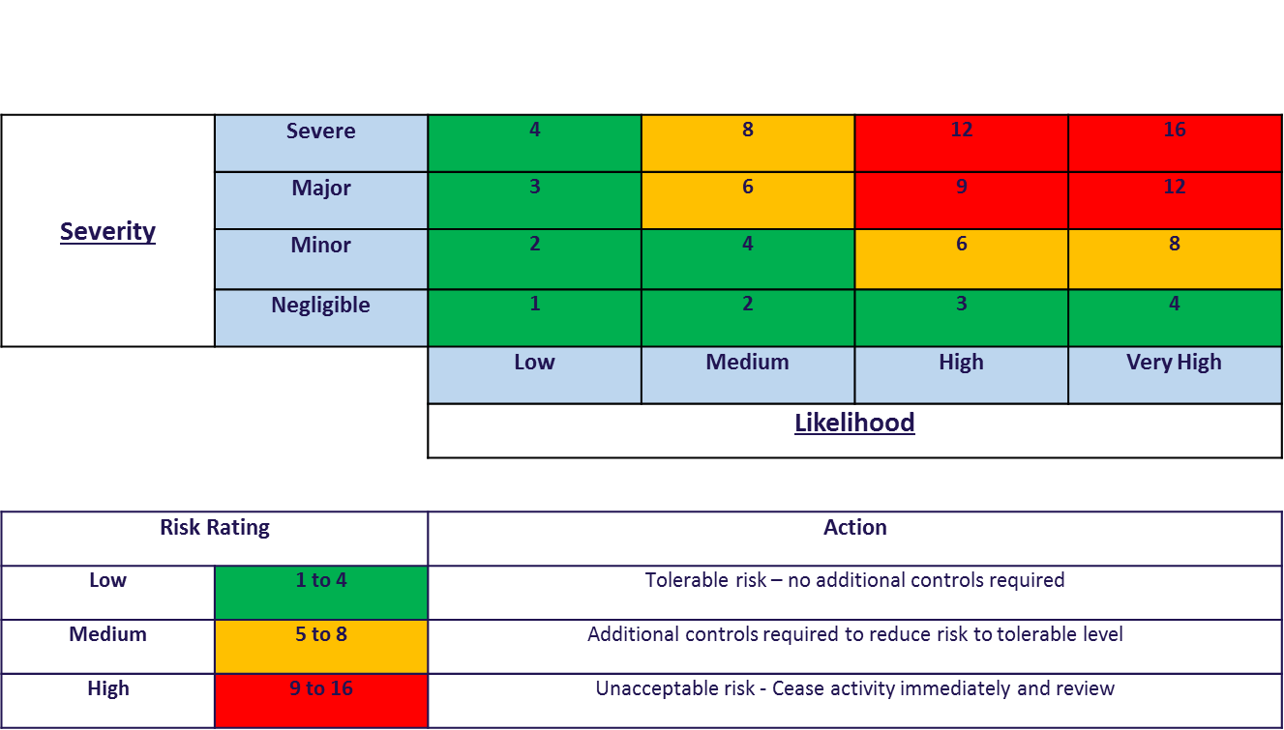
Risk Assessment Matrix

Hazard: Something that has the potential to cause harm
Risk: The likelihood of someone being harmed
To calculate the Risk Rating for the assessment form then use the following equation based on the matrix
Risk Rating = Severity x Likelihood

Risk Assessment Template

Club Name: ?? Bowling & Sports Club Ltd |  | Assessment No: | Date:
Assessed by: Mrs A.J Cumine  Assoc Professor, Chartered Physiotherapist, Teaching Fellow.  (MA,Bed Hons, Grad Dip Phys, HCPC, MCSP, HETf, BASRaT)  Assisted by Mrs D Slaughter  Signature: | Location: ? Bowling Club | Activity: Return to sport following COVID 19.  Proposed adaptations following the Government’s first steps to ease lockdown restrictions in England (10/5/2020) | Review date: 13/05/2020

What has the potential  To cause harm (hazards) and what harm might result? | Who and how many people might be at risk? | What measures are already in place?  (In place up to shutdown of club due to Coronavirus on 16 March 2020) | Severity | Likelihood | Risk rating | Further action required, by whom, timescale or reference to other documents plus information
Risk of transmission of COVID 19 as a result of lack of social distancing and equipment contact from asymptomatic players | All players who enter onto the Club outdoor premises. | Players have entered the car park, club green and freely associated with others.  Local residents/sports club users have used the car park as a cut through and sat on benches during the lockdown. |  |  |  | Player’s will be required to sign and adhere to the Self Declaration form (see attached)  This will relate mainly to social distances and only being on the premises for practise sessions,  Notices to be placed on both car park exits and both sides of the gates.
Risk of transmission of COVID 19 as a result of lack of social distancing and equipment contact from asymptomatic players | All players who play on the green | Players have freely used club equipment (mats and jack) and touched club surfaces (doors, chair arms, railings, entered the clubhouse) |  |  |  | Players will be required to disinfect before and after all equipment and surface that they have touched. The clubhouse will be closed with the exception of the toilets (for emergencies).
Risk of Transmission of COVID 19 as a result of lack of social distancing and equipment contact from asymptomatic players | All players who enter and/or play on the green | Players have freely turned up for rolls ups and practice sessions |  |  |  | Players will be required to book their practice session 24hours in advance.  No more than 6 players will be there in any single session. Volume will be controlled by playing on alternate days to reduce the risk of transmission.
Risk of Transmission of COVID 19 as a result of lack of social distancing and equipment contact from asymptomatic players. | All players who play on the green | Movement on the rinks has not involved social distancing or controlled who plays with who. |  |  |  | Following Government Guidelines (10/5/202) only solo practise and practise with people from the same household is allowed at this point  Only three rinks will be used at a time to decrease the risk of active transmission.
Risk of Transmission of COVID 19 as a result of lack of social distancing and equipment contact from asymptomatic players. | All players who play on the green | Players have not had to adhere to any player guidelines other than Club and Governing Body guidelines to date |  |  |  | Education with regards player safety will take three forms:  - Guidelines for Playing (see attached)  - Initial Walk through (Health & Safety)  - Video to demonstrate physical/social distancing protocols

